This brief examines two scenarios for heat pump deployment in the European Union (EU27): one of fast deployment, in which all European Commission targets are met on time, and another of slow deployment, in which only long-term targets are eventually achieved.

The EU has set ambitious deadlines for the adoption of heat pumps (HP) in Europe:
- 2030 TARGET (REPowerEU Action Plan, May 2022): Install 30 million (M) new HPs by 2030. The EU27 stock of HPs at the end of 2022 was 18.65M, so the target is to have a minimum of around 50M units in operation by the end of 2030. Industry actors rise this figure to 60M units.
- 2040 TARGET (Directive EU 2024/1275): Phase out fossil fuel boilers in buildings by 2040. There are around 84M boilers operating in the EU27 (79.5M gas + 4.5M oil). Based on the heat pump stock at the end of 2024 (21.41 million), this target implies having at least 105M heat pumps in operation by 2040

Whether these objectives are met will depend on future sales of HPs, which are determined by factors like the electricity-to-gas price ratio, government incentives, inflation, disposable income, etc. While long-term predictions of these variables are inherently uncertain, we can still explore what the future might hold by constructing two theoretical scenarios (Figure 1).

TARGETED SCENARIO: Targets are fully achieved. The stock evolution over the years is modeled using a logistic innovation adoption curve.

LINEAR TREND: Targets are not achieved. The stock follows its historical linear trend (average sales = 1.79M/year) before gradually aligning with the long-term goal
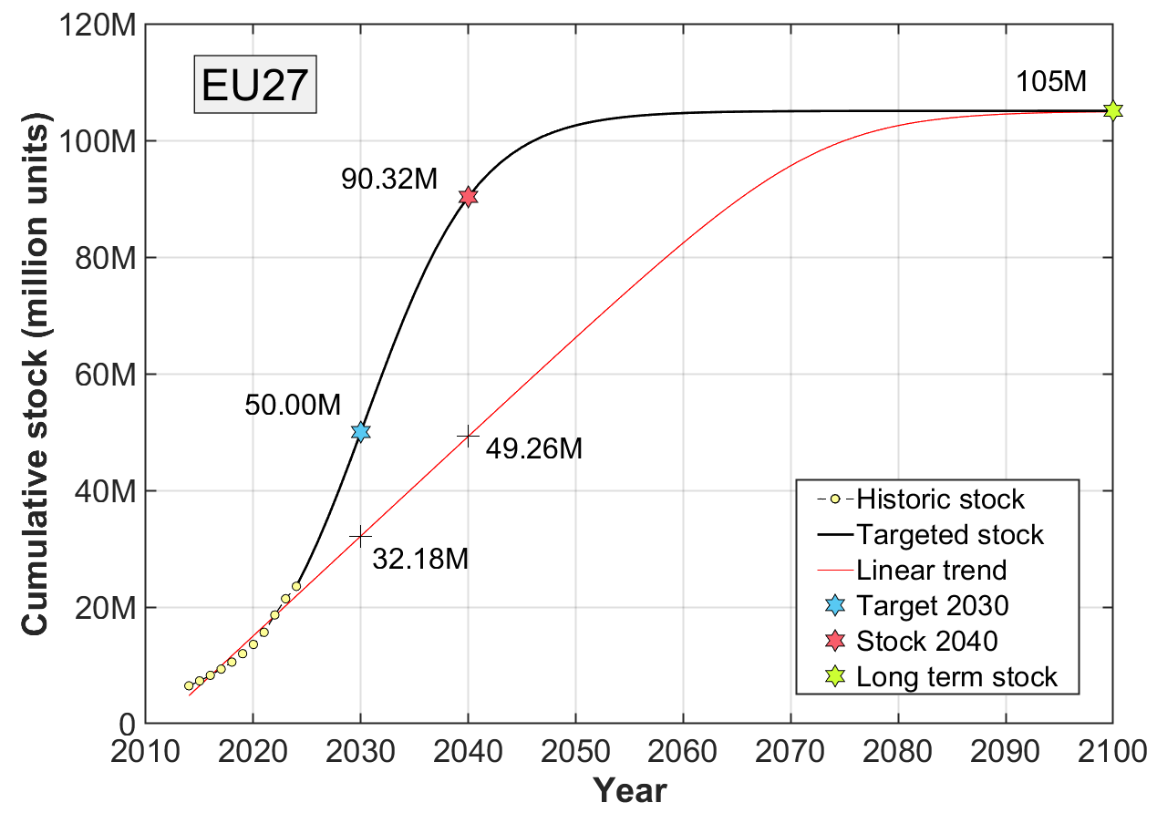  Figure 1: Two hypothetical projections of future heat pump stock | WHAT ABOUT THE 2040 TARGET?  As shown in Figure 1, our calculations do not impose the 2040 target as a strict constraint. Instead, it is treated as an asymptotic benchmark reflecting the long-term policy objective. The full phase-out of fossil fuel boilers is expected to proceed at a gradual pace, given their current sustained high sales volumes in several EU member states. By 2040 most of the boilers should have been replaced (stock = 90.3M) and by 2050 the process should be almost completed (stock = 102.6M)
Annual sales are shown in Figure 2 (targeted scenario) and Figure 3 (linear trend). Total sales are sum of two components:
- Sales of new units that replace old boilers and possibly other heating systems (coal, direct electric, etc.)
- Replacement of broken heat pumps. The time frame of the analysis is long enough for existing heat pumps to break down and require replacement. While this does not increase the total stock, it does contribute to overall sales.
To estimate replacements, heat pump lifetime was modelled as a normal distribution with a mean of 20 years and a standard deviation of 5 years, truncated at ±3 sigma. This probability distribution was convoluted with new sales data to estimate the number of heat pumps failing each year. The model accounts for the replacement of new heat pumps entering the market, as well as future replacement of previously replaced units.

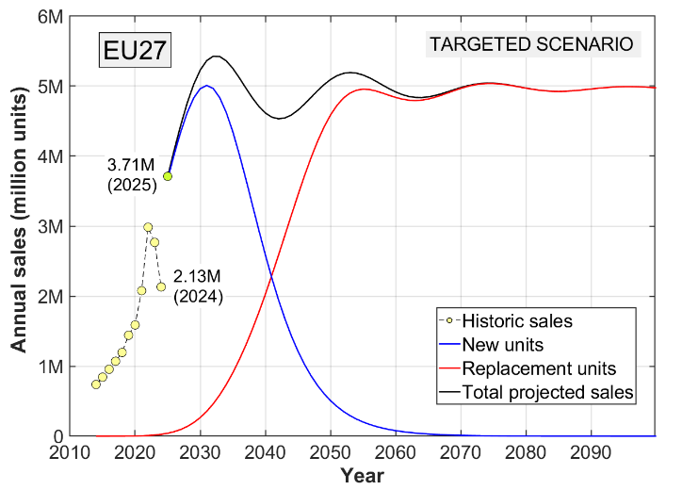  Figure 2: Possible path for annual sales that fully meet the stock targets | 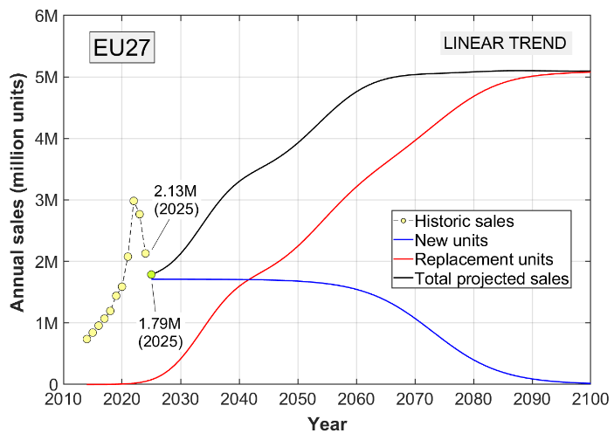  Figure 3: Annual sales when sales of new unit follow the historic average

To meet the number of heat pumps required to achieve the 2030 target, the EU must more than double the annual deployment rate: sales need to jump from 2.13 million units in 2024 to 3.71 million in 2025, then continue increasing each year until peaking at 5 million new units in 2031 (5.4M units including replacement). From that point, sales of new units replacing old boilers will gradually decline, while sales of heat pumps replacing broken ones will begin to rise, eventually becoming the main driver of total sales by 2050. In the long term, total sales will stabilize at around 5 million units per year. It is important to note that this calculation does not include organic growth in demand, such as sales driven by demographic trends (new buildings for a growing population). This is why new unit sales drop to zero.

Given the decline in sales in 2023 and 2024, and based on the calculations presented above, heat pump deployment plans are unlikely to come true without decisive action from the EU and national authorities. Long-term policy clarity, a roadmap to phase out fossil fuel heating, and measures to keep electricity prices competitive are essential to get back on track.

More information on this document: Author (Fernando Dominguez, University of Malaga -Spain, fdominguezm@uma.es); Project’s coordinator (Egidijus Babilas, Lithuanian Energy Institute, egidijus.babilas@lei.lt)

Toleikyte, A. e. (2023). The Heat Pump Wave: Opportunities and Challenges, Publications Office of the European Union. Publications Office of the European Union.

